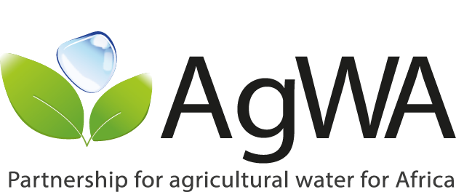

AgWA Steering Committee/Partners’ Meeting
March, 18-19th 2014, Addis Ababa, Ethiopia

Agenda

DAY 1: March 18th 2014 – Steering Committee Meeting
Session 1: Opening and Introductions
09.00 – 9.30 | - Welcome and opening remarks  - Presentation of Participants  - AgWA - A Mature Partnership for Scaling up Agricultural Water Management in Africa | FAO-SFE/Addis Ababa  AgWA Secretariat
Session 2: AgWA Progress 2012-2013
09.30 – 10.30 | - AgWA Progress during 2012/2013  Presentation  Discussion | AgWA Secretariat
Tea/Coffee Break
Session 3: AgWA Governance and Implementation Architecture
11.00 – 12.30 | - AgWA’s Operational Plan 2014/2015  Discussion and Decisions on AgWA’s Operational Plan 2014/2015 | FAO-NRL/HQs-Rome
Lunch
Session 4: AgWA Operational Plan 2014/2015
13.30 – 15.00 | - AgWA Governance  Presentation  Discussion and Decisions on AgWA Governance for 2014/2015 | AgWA Secretariat
Tea/Coffee Break
Session 5: AgWA Financing Plan 2014/2015
15.30 – 17.00 | - AgWA Financing Plan 2014/2015 – Presentation  Discussion and Decisions on AgWA Financing Plan 2014/2015 | FAO-NRL/HQs-Rome
17.00 – 17.30 | Summary of decisions taken | FAO-NRL/HQs-Rome

Day 2: March 19th 2014 – Partners/Business Meeting
09.00 – 10.30 | - Partners’ Contributions to Operational Plan  Decisions on Partners’ contributions | All
Tea/Coffee Break
11.00 – 12.30 | - Refinement of Financing Plan for 2014-2015  - Partners’ Commitments, Roles and Responsibilities | All
12.30 – 13.00 | - Summary of decisions taken and next steps  - Closing Statement | AgWA Secretariat  FAO-NRL/HQs-Rome  FAO-SFE/Addis Ababa
Lunch

